**RESERVATION HUB: NESTED CHATBOT**

***Assistant professor :Akash Goel***

***B.Tech Scholars : Lokesh Verma , Kritika Dubey, Khushi Chandelia***

***Department of Computer Science, KIET Group of Institutions***

***Abstract: In today’s world , website that can speed up the life of humans is more dominated over slow and average working websiteb. People needs to reserve their seats to travel comfortably for this easy and online booking of seats are required .to make this process easy A reservation website along with chatbot is implemented .Machines are working similar to humans because of advanced technological concepts.The technology used for the advancement of conversational agent is natural language processing (NLP). Website will work to provide hands on processing to users of reservation. Machines are used for development of technology Chatbot is also one of this type of machine which can hear the voice of humans and translate them to machine language which make the process and communication and working with website very prominent . chatbot will be using NLP(natural language processing) . and ML(machine learning)for proper functioning.***

**I. INTRODUCTION**

Reservation Hub is providing a place where user can book their seats in trains and also can ask their queries and train status. So, to simplify this process we have introduced a chatbot on reservation site. Taking in consideration to the above discuss purpose our team has come up with a better way to represent the reservation status. Implementation of chatbot in the website being lightweight and nimble seemed adept for this situation. Using the power of chatbot to serve travel related information in a quick and easy to consume format. It is fast and concise and also it provides easy way to the passenger to get the queries.

**II. LITERATURE REVIEW**

The IRCTC website of Indian Railways does not have a proper chatbot. After looking the condition of chatbot our team decided to make a clone website of Indian Railways with the implementaion of chatbot . This chatbot will be fast andϖ responsive. Customers can easily ask their queries in that chatbot and these queries will be solved in more effective manner. This will make reservation process and queries solving process more better and helpful for the customers. Website will have more added features than the existing one which will provide better experience. Taking in consideration to the above discussed problem our team has come up with a better way to present the Reservation status. Implementation of Chatbot in theϖ website, being lightweight and nimble seemed adept for this situation. Using the power of chatbots to serve travel related information in a quick and easy to consume format. The Functioning of chatbot will be fast and very concise and it will be compatible for customers. Chatbot will solve all customer queries and provide multiple languages like Hindi and English in which customer can tell their queries. Chatbot will solve all customer queries and provide better and improvised experience to users. It will provide multiple languagesϖ like Hindi and English in which customer can tell their queries. Website will have features which areϖ more responsive and effective to users. Website will keep record of data of allϖ users and transactions record are also saved in database. This will provide better suggestionsϖ which are user friendly and beneficial for customers. Chatbot will provide flexibility to users to ask all reservation related queries.

**III.PROBLEM STATEMENT**

Besides Booking ticket, IRCTC also provide customers to check the Passenger Name Record(PNR) status, Running Status of Train, and Train Schedule. Chatbot will provide information to users about booking of seats and provide better recommendations about train and timings .Existing website have loading problems and have lower throughput , Current website do not provide better recommendations and is more time consuming.

**IV.WORK PLAN**

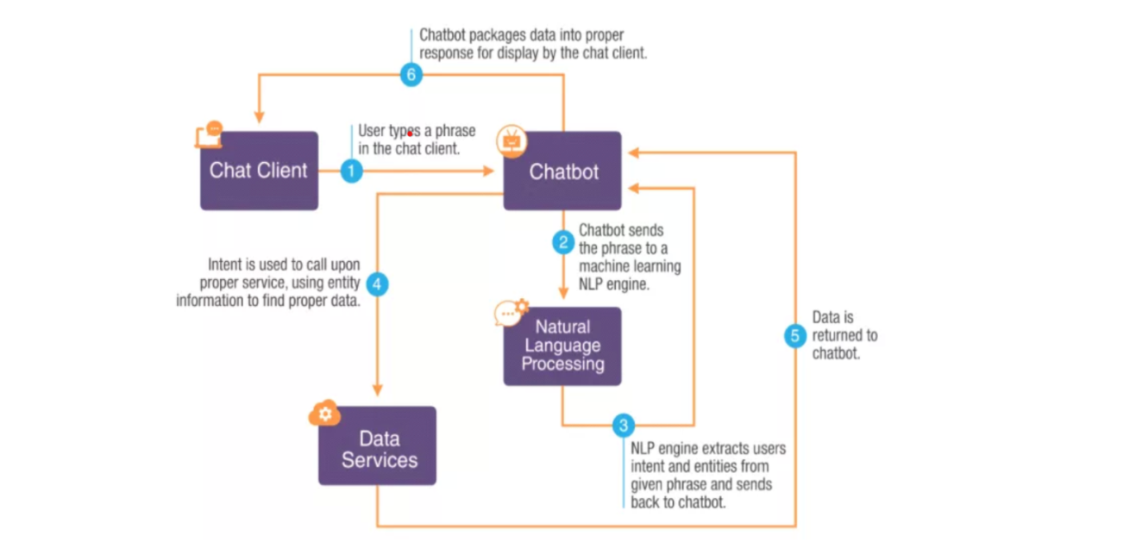

1. User will first visit the website page using Website Url.
2. There if user is new then it will sign off and create their account .
3. If user is existing it will sign in.
4. After sign in user will be able to check for their trains and booking.
5. They can also use Chatbot to ask their queries.
6. Website will also provide better recommendations.
7. After Booking data of user will save in database.
8. Now User can log out from their account.

**V.METHADLOGY**

1. End users of website are customers which will visit website for reservation.
2. When users visit the website first they will have to create their account if they are new users.
3. They can also sign in to website if they are existing users.
4. Now users can book their seats after checking seat availability for particular train for a particular day.
5. Users can also ask help from Chabot for train status and booking confirmation.
6. Chatbot will resolve all reservation related queries of users.

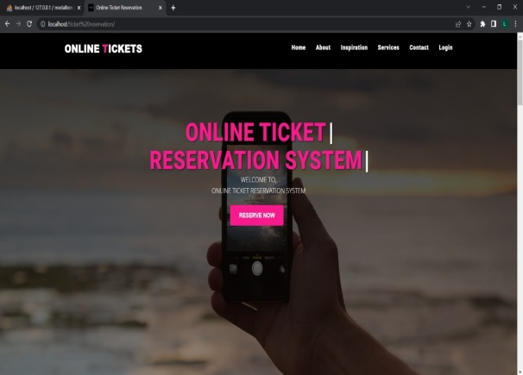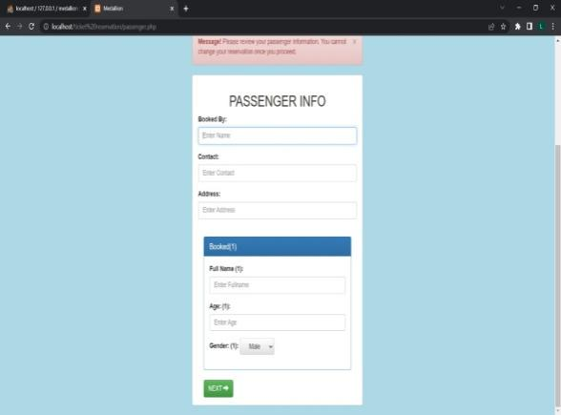

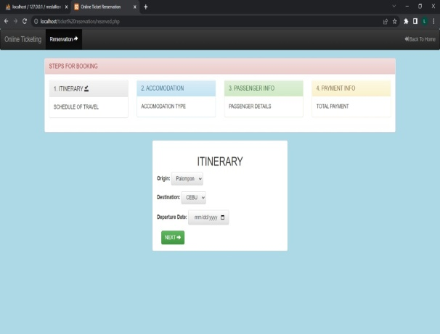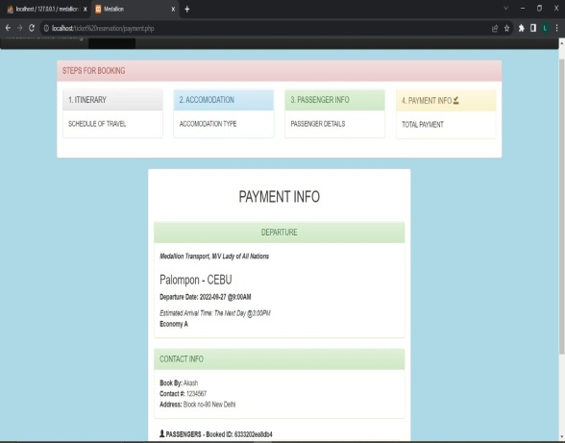

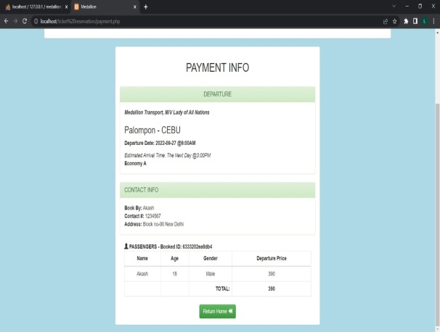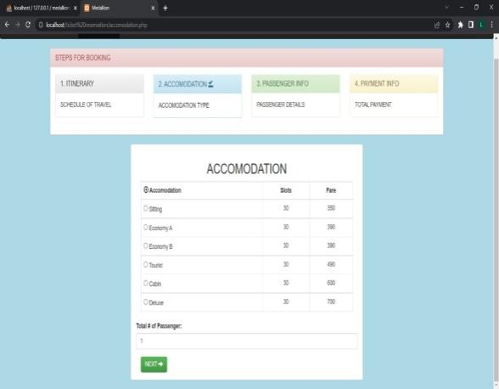

Fig 2. Reservation Hub WebPage

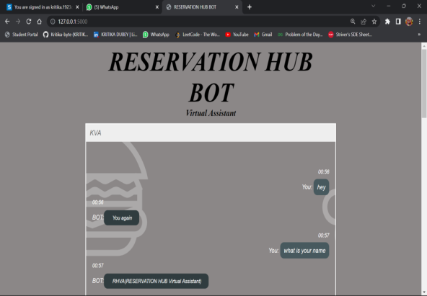 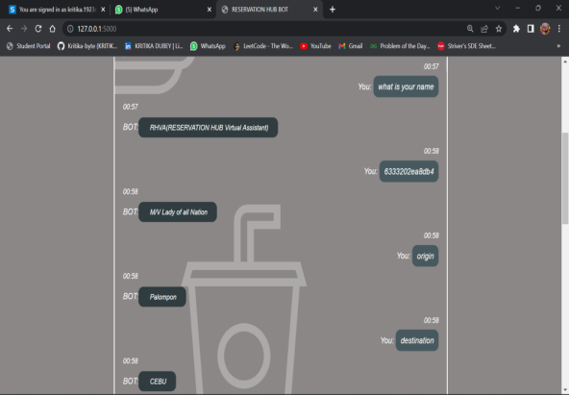

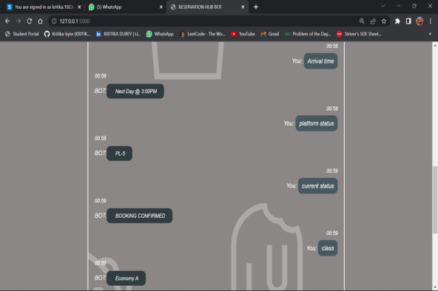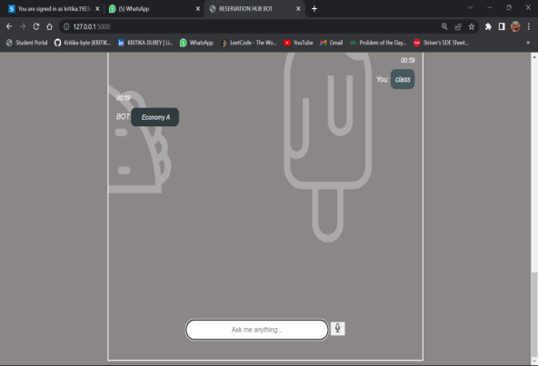

Fig 3. Reservation Hub Chatbot

***Advantages:***

1. This website will reduce the work of Admin to much extent.
2. This website will Maximise the reservations and reduce no-shows.
3. This will increase payment speed and security.
4. This will help admin to seek into data insights which help users for better performance.
5. Chatbot will be operable in both languages that is Hindi and English.
6. Throughput of website will be large so it can handle large number of users.
7. Website will provide fast and Hassle Free booking of tickets.

**VI.TECHNOLOGY USED**

1. We are using HTML, CSS, JavaScript Library(REACT.JS) and framework(ANGULAR) for client side programming and for making frontend part of website.
2. PHP for server-side programming and for Backend part of website.
3. MYSQL for Databases and storing various data of customers which can be retrieve easily whenever require for information.
4. We are using MACHINE LEARNING concept for Chatbot.
5. Implementation of Chatbot in Website will take place through python programming languages.

**VII.CONCLUSION**

This website is more effective in working . it has fast loading speed and provide better experience to users who are more fond of online reservation. This website is more user friendly and attract users to visit website and do all their booking . they will easily able to see seats availability and timings of train . website will provide better recommendations which are useful for users.They can check the status of train easily and can track train location . Users are provided with chatbot which will provide all queries to users about train and booking.They can also use voice recognition feature for better experience of chatbot.

**VIII.REFERENCES**

[1]. Ravi Santosh Arvapally, Hasan Hicsasmaz, Wally Lo Faro-―Artificial Intelligence Applied to Challenges in the Fields of Operations and Customer Support‖, Issue, 2017.

[2]. Daniel Toniuc and Adrian Groz- ―Climebot: an argumentative agent for climate change‖, Issue, 2017

[3]. Cyril Joe Baby, Faizan Ayyub Khan, Swathi J.N.- ―Home Automation using IoT and a Chatbot using Natural Language Processing‖, Issue , 2017

[4]. Naveen Kumar M, Linga Chandar P C, Venkatesh Prasad A, Sumangali K-―Android Based Educational Chatbot for Visually Impaired People‖, Issue, 2016

[5]. Sahaya Sakila.V, Akshat Shrivastava, Md Armanϖ Ansari- “RAILBOT: A Railway (IRCTC) Chatbot”,IJESC Issue, 2018.

[6]. Sasa Arsovski, Adrian David Cheok, MuniruIdris, Mohd RadzeeBin Abdul Raffur – “ANALYSIS OF THE CHATBOT OPEN SOURCE LANGUAGES AIML AND CHATSCRIPT: A Review” , Issue, 2017.

[7]. Jinsy Susan Thomas, Prof. Seena Thomas,” Chatbot Using Gated End-to-End Memory Networks”, International Research Journal of Engineering and Technology (IRJET), Volume: 05 Issue: 03 | Mar 2018.  
[8]. Aafiya Shaikh, Dipti More, Ruchika Puttoo, SayliShrivastav,, Prof , Swati Shinde,” A Survey Paper on Chatbots.” International Research Journal of Engineering and Technology (IRJET) , Volume: 04 Issue: 05 | May 2017.

[9].Ashok, G., Brian, C., Mithun, K., Shanu, S., Abhinaya, S., & Bryan, W. (2015). Using Watson for Enhancing Human-Computer Co-Creativity. AAAI Symposium: 22–29.

[10] M. H. Su, C. H. Wu, K.-Y. Huang, Q. B. Hong, and H. M. Wang, “A chatbot using LSTM-based multi-layer embedding for elderly care,” in 2017 International Conference on Orange Technologies (ICOT), 2017, pp. 70–74.

1. Egencia (2018). What is a Chatbot and How does it work? Retrieved March 9, 2019

[12]Hattie, J. (2012). Visible learning for teachers: Maximizing impact on learning: Routledge. https://chatbotsmagazine.com/a-visual-history-of-chatbots-8bf3b31dbfb2  
[13] B. P. Kiptonui, “Chatbot Technology: A Possible Means of Unlocking Student Potential to Learn How to Learn, Educational Research”, Vol.4, Issue.2, pp. 218-221, 2013.

[14] BORKAN, "www.blog.casper.com," 21 september 2016.

[15] R. S. Russell, “Language Use, Personality and True Conversational Interfaces”, Project Report of AI and CSUniversity of Edinburgh, Edinburgh, pp.1-80, 2002.